Tournament of Roses 2019
Packing List
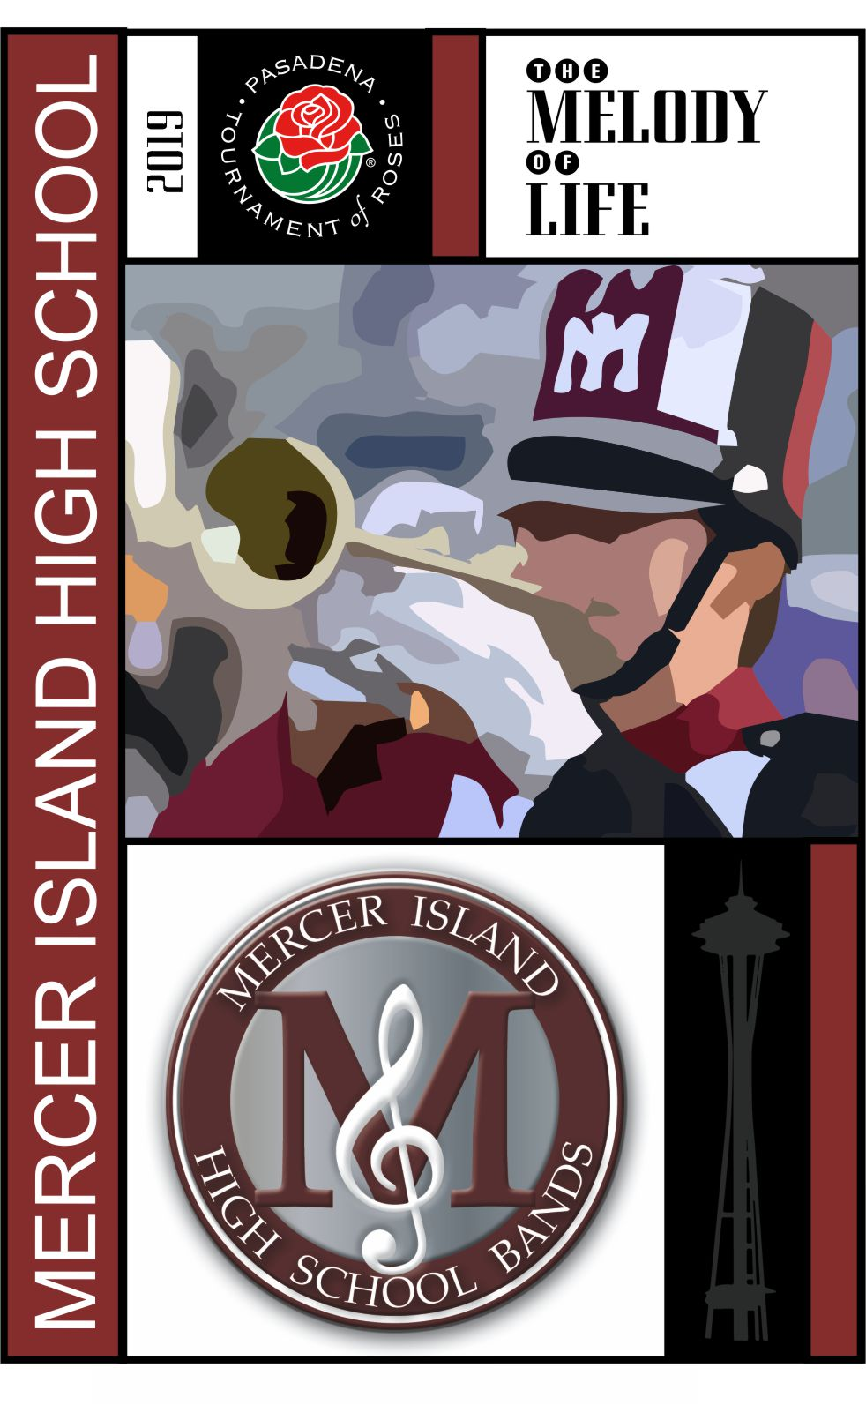

On departure day – wear your maroon MIHS Band travel wear jacket

Packed in a carry-on please – no checked luggage
- Flight groups A,B,C,D maximum size 22”x14”x9”
- Flight groups E,F maximum size 24”x16”x10”

Pack these things
Marching Band uniform essentials:
- Dinkles
- Black socks
- Black marching band shirt
- Leggings, under armour, shorts, etc – something ‘sleek’ (i.e. no jeans, sweats under uniform)
Comfortable touring clothes for Pasadena weather – 45 to 85 degrees on average this time of year
- Pair of jeans
- Pair of shorts
- Two-three tshirts
- Comfortable walking shoes (at Disneyland, at Universal Studios, etc)
- A warmish sweatshirt (it can get cold in southern California in the evenings)
Pajamas
Toiletries
MIHS TofR pins
MIHS-BEG tshirt
Empty water bottle (to fill at the hotel each day)

Something to entertain you on the plain and the bus rides
Cash for incidentals (all your meals and expenses are included in the trip) such as snacks, souvenirs, etc.

